Expense Splitter App Report

Members: 20SW001(individual)

The Problem
You know, sometimes when you go out with friends or family, you spend money on things like food, tickets, or toys. But then, you forget who paid for what, and you don't know how to share the costs fairly. It's like a puzzle, and sometimes it makes people confused and upset. This is a real problem that we noticed, and we wanted to find a solution.

New Idea

So, I thought about it, and I made something awesome! We created an app called the "Expense Splitter." It's like a magic tool that helps you remember who paid for what and how much. You can tell the app how much you spent, what you bought, and when you bought it. Then, it does the math for you and keeps track of everything.

Screenshot of app
The app has three screen,
Firebase Authentication
HomeScreen
The Expense Entry Screen
Here are some pictures to show you how it looks:

Homepage:

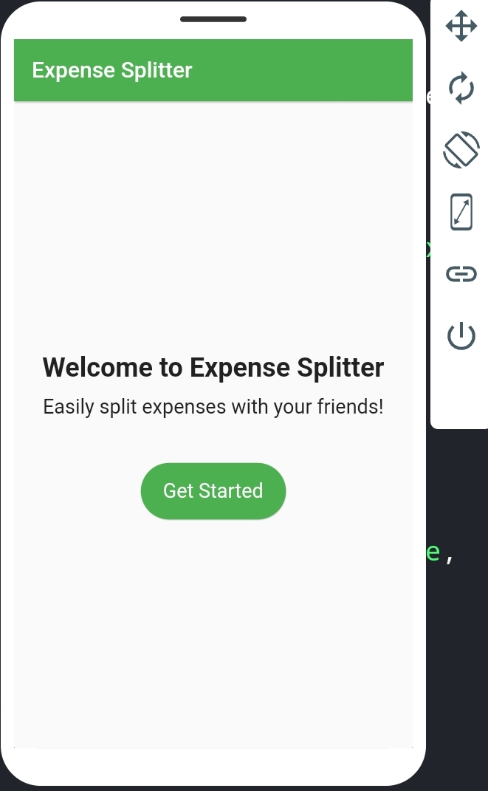

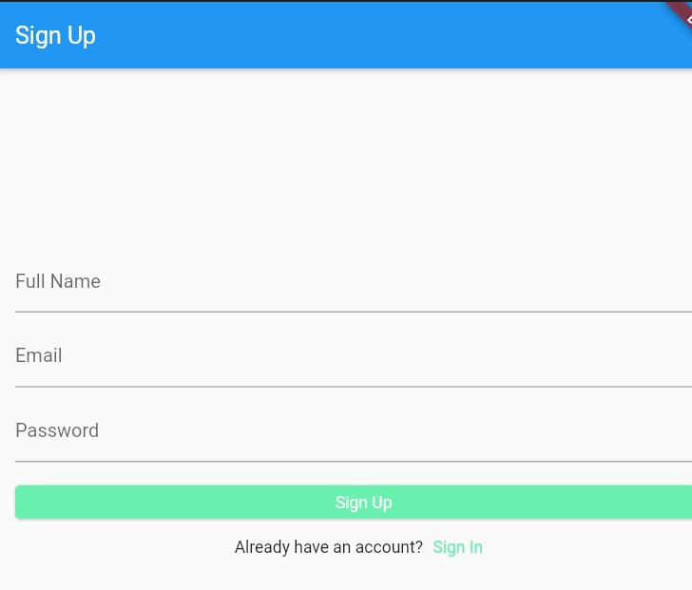

Authentication Screen:

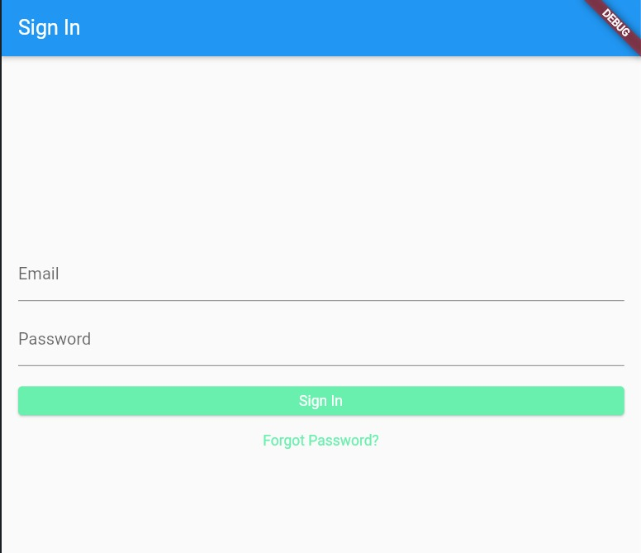

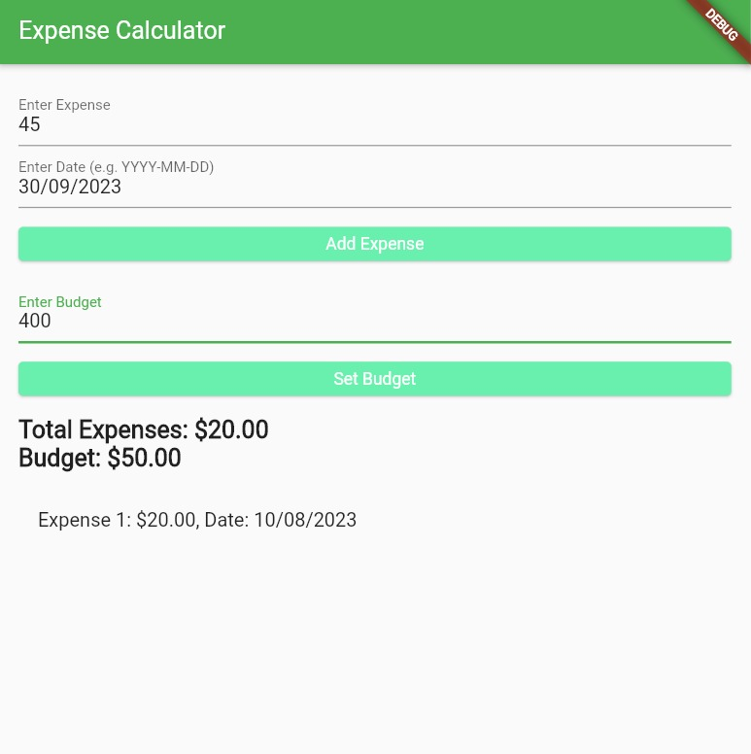

Expense Entry Screen:

How I Keep Your Stuff Safe

To make sure your information stays safe, we use a special notebook called SQLite. It's like a tiny, speedy, and reliable diary for your expenses. It helps us remember all the money stuff for you.

Helping tools:

While I made this app, I got some tools to help me:

firebase_auth: This tool makes sure you log in safely. It lets you use your email and secret password to get in.

sqflite and path: These tools make SQLite even better. They help us keep your expense records neat and tidy.

Bugs and Problems:
When I was making the app, I ran into some problems, like:

Setting Up the Super Safe Login: I wanted to make sure no one sneaks into your app. So, I worked hard to make the login part super safe.

Picking Dates Was Tricky: At first, picking dates was like trying to catch a firefly. But I made it work really well in the end.

Checking What You Type: I had to make sure you don't put weird stuff in, especially how much money you spent. I made the app really smart about that.

Moving Around the App: Sometimes, it was a little tricky to move from one part of the app to another. But don't worry, I fixed it, and now you can go everywhere easily.

I wanted to make sure the app works super well and helps you with your money without any problems.

My Expense Splitter app is like your friendly helper. It's here to solve the problem of sharing money with friends and family. The app is easy to use, looks nice on all your gadgets, and keeps your money stuff safe. I fixed all the tough parts while I was making it, so you can use it without any worries.

